**Grove - Light Sensor**

窗体顶端

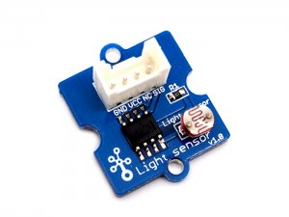

http://www.seeedstudio.com/depot/includes/templates/pure_green/images/next_l.gif

* [http://www.seeedstudio.com/depot/bmz_cache/9/9c2b8e216f29574e063f14189fea1e54.image.55x41.jpg](http://www.seeedstudio.com/depot/images/P2100711.jpg)

http://www.seeedstudio.com/depot/includes/templates/pure_green/images/next_r.gif

* **Price:**

$2.90  [(Price Feedback)](javascript:void())

* **SKU:**

SEN11302P

* **Weight:**

5Gram

* **Units in Stock**

52

* **Designed by:**

[Seeed Studio](http://www.seeedstudio.com/)



[Other products from designer](http://www.seeedstudio.com/depot/seeed-studio-m-23.html)

* **Quantity:** Max: 52  
  
* [Add to Wish List](http://www.seeedstudio.com/depot/index.php?main_page=un_wishlist&products_id=746&cPath=144_148&action=un_add_wishlist)

Description

The Light sensor module uses the GL5528 photoresistor to detect the light intensity of the environment. The resistance of the sensor decreases when the light intensity of the environment increases. The chip LM358 is used as a voltage follower to enable you get a accurate data.

**Features**

* Grove compatible interface
* Wide supply voltage range: 3V-30V
* Miniature HID part

**Applications Ideas**

* Electronic toys
* Light-control switch
* Monitor

**Documents**

Please visit our[wiki page](http://www.seeedstudio.com/wiki/Grove_-_Light_Sensor) for more info about this product. It will be appreciated if you can help us improve the documents, add more demo code or tutorials. For technical support, please post your questions to our [forum](http://www.seeedstudio.com/forum).

窗体底端